**23.2.1**

jewelry: /ˈdʒuːəlri/ trang sức

necklace : /ˈnekləs/ dây chuyền

Hey

Hey there

Do you have plan for lunch?

No, I don’t.

Do you want to go shoping with me during lunch?

Where?

I have to go to the department store cross the street. I need to buy a few thing.

Yes. I want to go. **I need to buy a new handbag.**

Uh. Come with me.

Ok.

What do you want to buy?

**I want to get some jewelry.**

**I love jewelry. I like rings.**

Uh. **I like rings but I really like earring.**

They are nice. **I aslo like a necklace**.

Thanks

You have so much jewelry. You don’t need new jewelry.

I know. I don’t need this but I want it.It make me feel good.

Can you get me new tie when you're there? I got mustard on mine.

Yes.

**Go to the mall uptown**

We want to go to the mall across the street. **We can walk to the mall across the street**. **But we can’t go buy food to the mall uptown.**

No, **you need to take the bus to the mall uptown.**

**Buses are slow and never on time**. I take a train when you look at the schedule for the train it's always on time. We can get them in 10 minutes.

We don’t have time to take a bus or take a train . We can walk to the mall across the street.

Ok.

Fine. some money for my tie. Thank you

You’re welcome

See you later

Aanya asks Khae to **go shoping**.

What does Khae need to buy?

-> A handbag

Why does Marco need a new tie?

-> He has mustard on his tie.

Khae and Aanya decide to walk to the mall across the street.

**Practice**

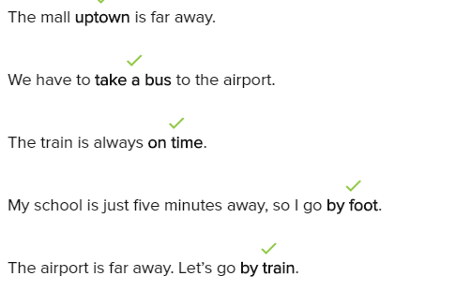

**Skill Practice**

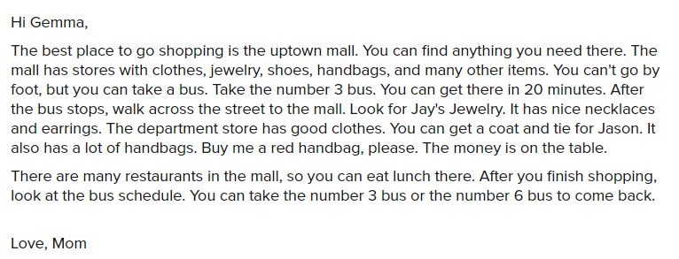

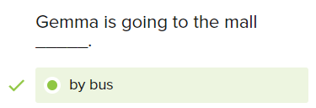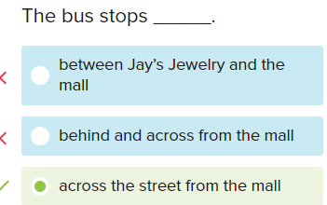

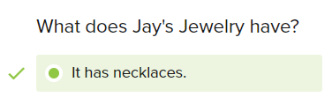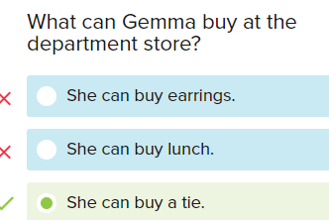

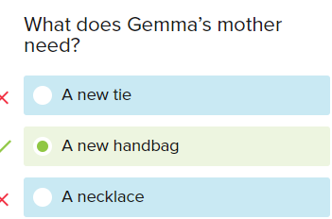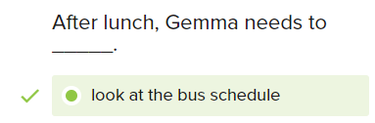

**Conversation**

What do you want to buy?

I want to buy some jewelry.

I see. What kind of jewelry do you want?

I want to buy necklace.

Here is a nice necklace. Do you like it?

Yes, I do. How much does it cost?

The cost is 200$

I see. How much is this ring?

The cost is 100$.

Thank you. I like a the ring, please.

Ok, Anything else?

Yes. I also want to buy some earring.

We have earring at the other store. It’s at the mall uptown

How do I get there?

You can take a bus or take a train.

Thank you. The bus is slow, so I have to take a train.

**Excersise**

She wears a ring on her finger.

You have to take a bus uptown.

Salesperson: What do you want to buy?

->Some jewelry

Jonas: Where are the car keys?

-> Claire: Look in my handbag.

The bus is late, so I’m not going to be on time.

A: How much is that tie?

B: It’s $50.

A: Do you like jewelry?

B: Yes, I love necklaces and rings.

A: How do I get to the mall uptown?

B: Take the bus.

The airport is far away, so we can’t go by foot.

Salesperson: How can I help you?

Lee: I want to buy some jewelry.